SATEL-GW600 Series User manual
SATEL-GW600

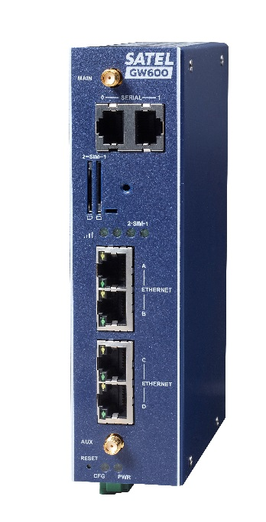

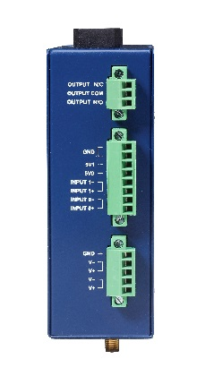

Issue: | 1.04
Date: | 30 November 2017

